**Functional Especifications**

**eViaticos – Mobile v1**

Table of contents

1. Screens Request 3

1.1. Requester 3

1.1.1. Request Information 3

1.1.2. Change Responsible 4

1.2. Company Card Replacement 5

1.2.1. Request Information 5

1.2.2. Send Request 6

1.3. Sales Force – Step Request 7

1.3.1. Path 7

1.3.2. Travel Expenses 8

*1.3.3.* Car Expenses 9

1.3.4. Send Request 10

1.4. Sales Force – Step Review 11

1.4.1. Path 11

1.4.2. Travel Expenses 12

1.4.3. Car Expenses 13

1.4.4. Signatures 14

1.4.5. Send Review 15

# Screens Request

## Requester

### Request Information

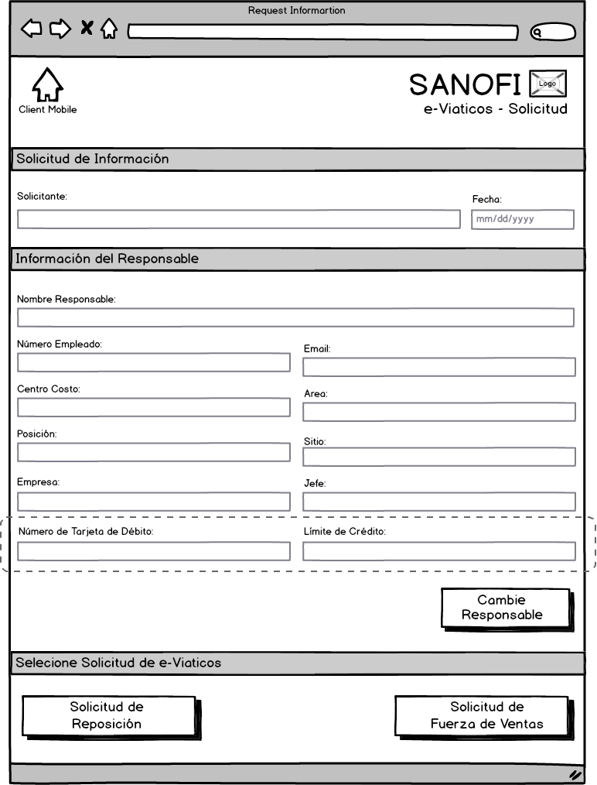

Solicitud de Fuerza de Ventas

Solicitud de Reposición

### Change Responsible

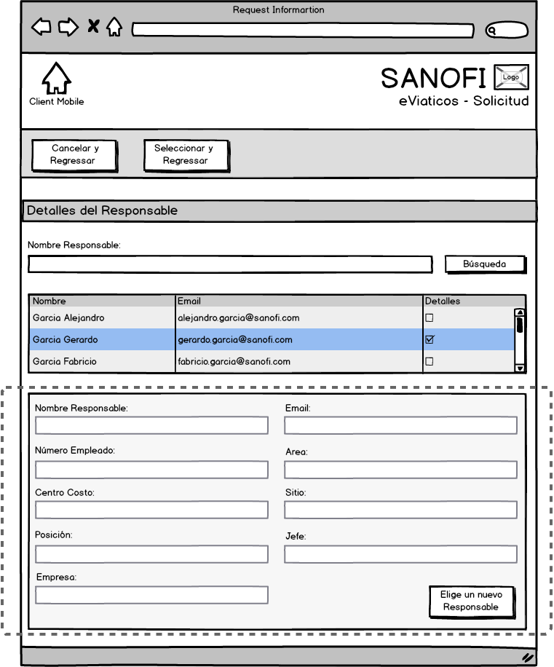

## Company Card Replacement

### Request Information

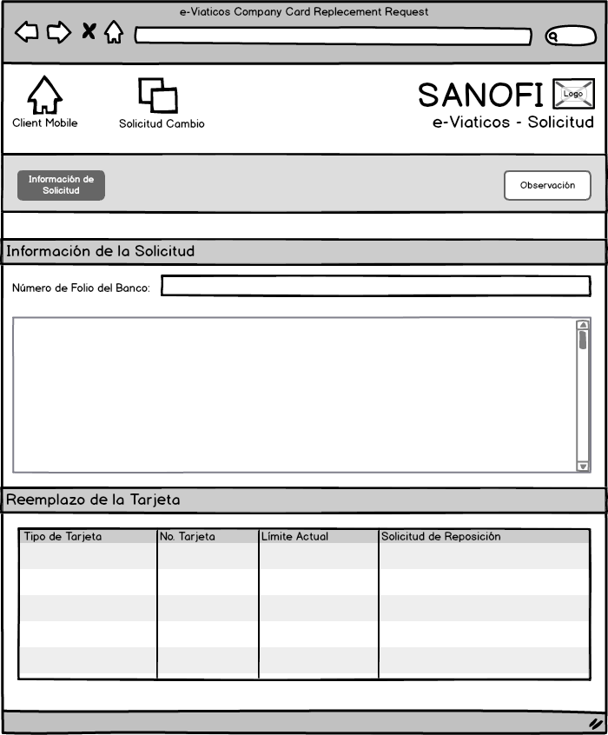

Observación

Tipo de Tarjeta No. Tarjeta Límite Actual Solicitud de Reposición

### Send Request

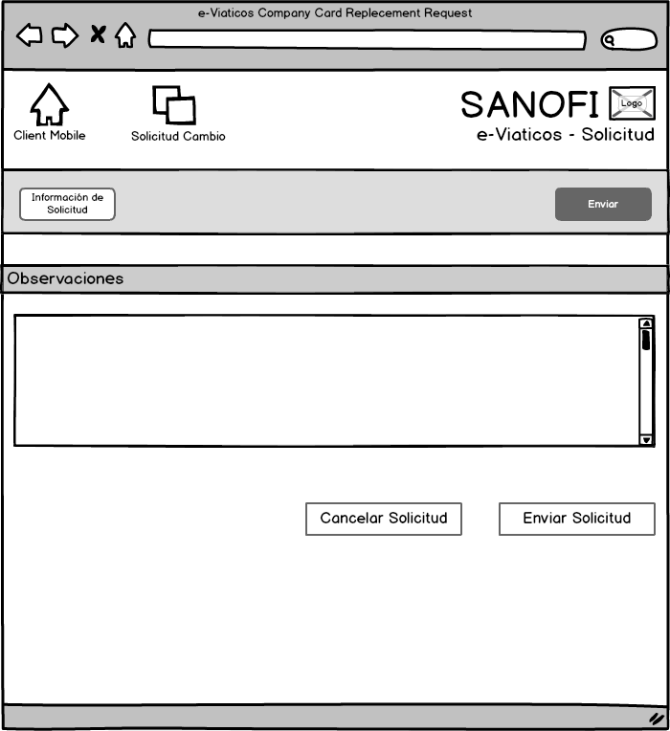

## Sales Force – Step Request

### Path

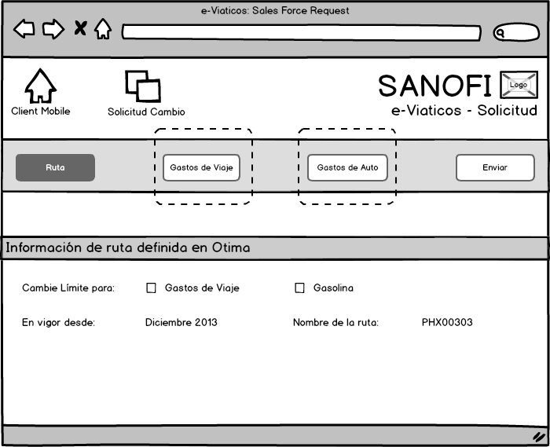

Gasolina

### Travel Expenses

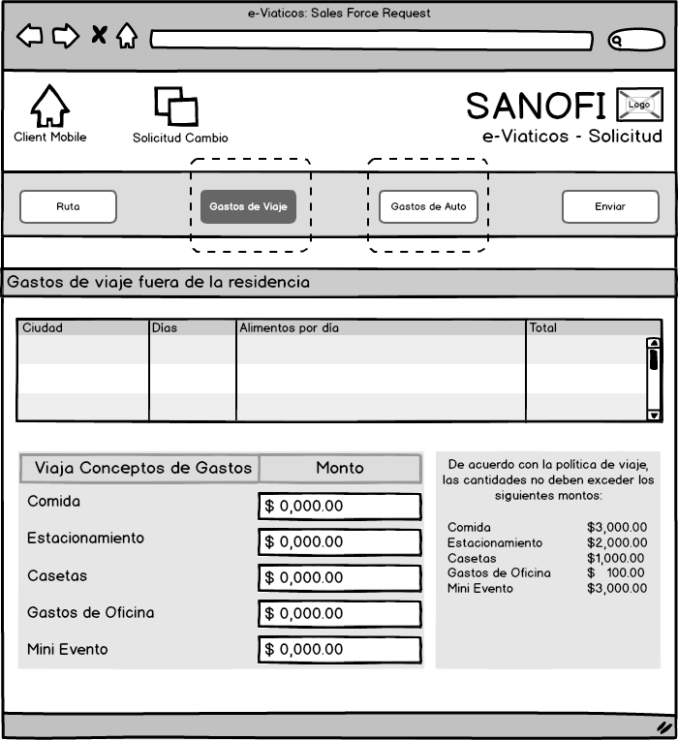

It could be more than three lines, so it is required a scroll bar.

Vamos a quitar esta columna de IVA

Casetas

Gastos de Oficina

De acuerdo con la política de viaje, las cantidades no deben exceder los siguientes montos:

Alimentos por día

### Car Expenses

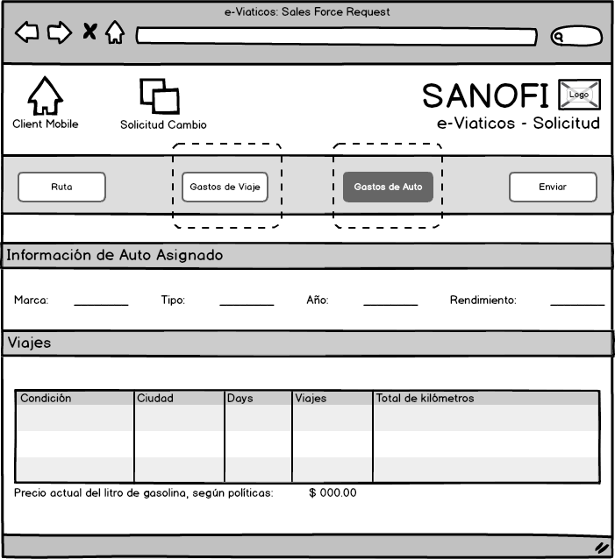

Precio actual del litro de gasolina, según políticas:

Información de auto asignado

### Send Request

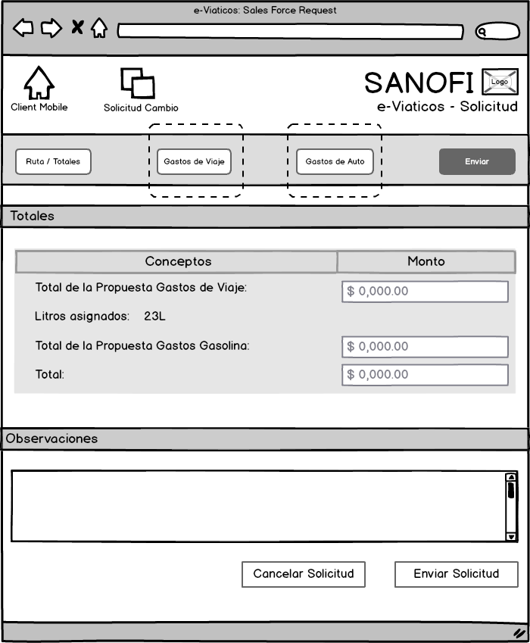

We should consider the Reject step, where the user can modify everything that is modifiable except to change the responsible. In this step the user should see the signatures screen.

The final buttons are:

“Cancelar solicitud” which end the flow and

“Enviar solicitud” which send the flow again.

We should show the amount of Oil liters, so I think we can add a line among travel expenses and Oil expenses and add a label that said:

“Litros asignados” and as label too the total of liters. Not in the “Monto” column because it is not an amount

These fields are read only

Gasolina

Conceptos

## Sales Force – Step Review

### Path

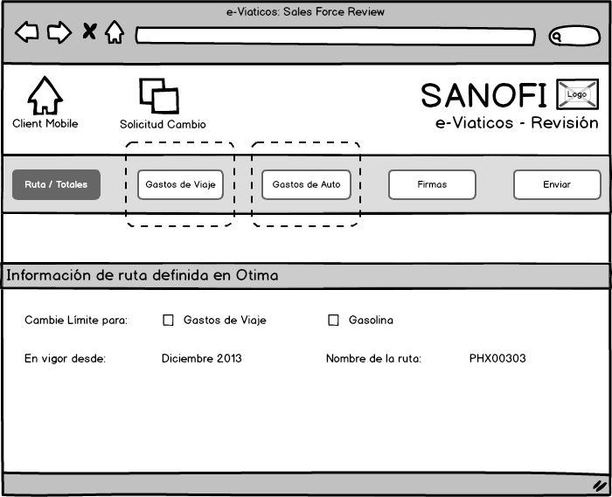

### Travel Expenses

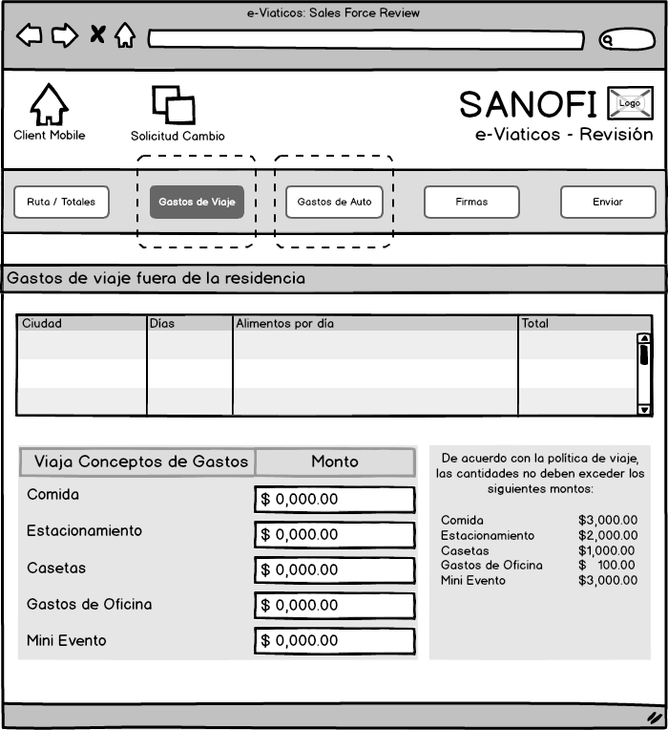

### Car Expenses

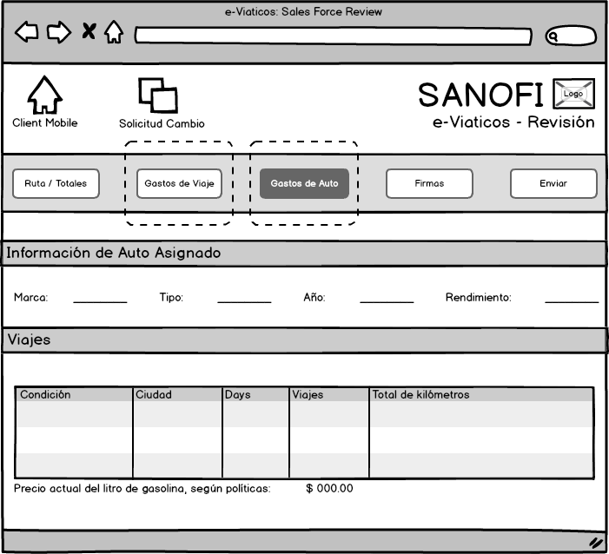

### Signatures

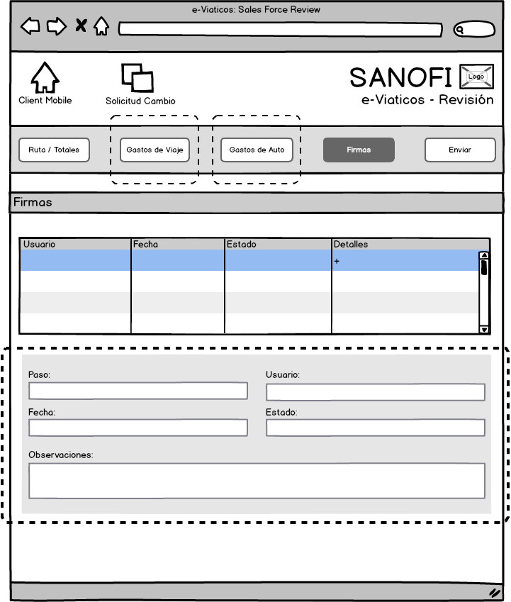

### Send Review

